Muhammad Tiamour Abdullah
Sp24-Bse-056
Information Security
Lab Mid

Question 1: Write a Python program to decrypt a message that was encrypted using the Caesar Cipher. The program should take ciphertext (LXFOPVEFRNHR) and key (5) as input and display the plaintext
Code:
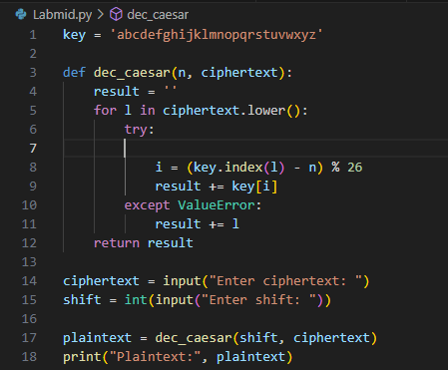
Output:
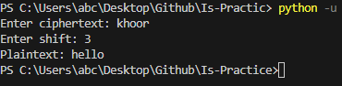
Question 3
Code:
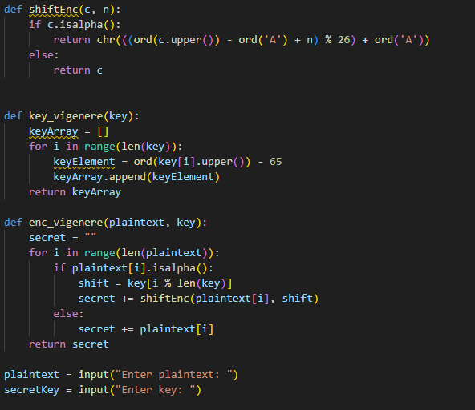
Output:
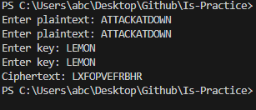
Question 4:
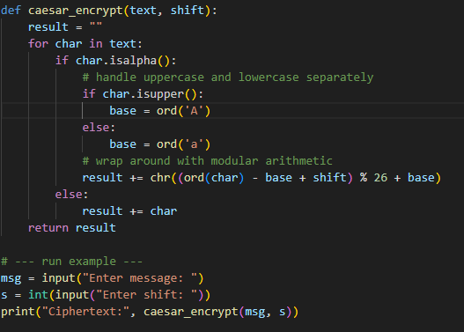
Output:
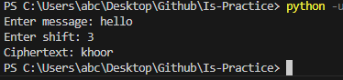
Problem and Solution:
ord(char) - base converts the letter to a number from 0 to 25.
+ shift moves it forward by the shift amount.
% 26 makes sure it wraps around (so z + 1 → a).
+ base converts the number back to the correct ASCII range for uppercase or lowercase.
Question: 4 a) Write one similarity between DES and AES. (2 marks)
b) What does CBC mode stand for in block ciphers? (2 marks)
c) Why is AES faster than DES? (1 mark)
- The Similarity Between both is DES and AES are symmetric key block ciphers, meaning they use the same key for encryption and decryption.
- CBC stands for Cipher Block Chaining : it is a mode of operation where each plaintext block is XORed with the previous ciphertext block before encryption.
- AES is faster than DES because it uses fewer and more efficient rounds with modern hardware optimization, while DES uses smaller 56-bit keys and slower bit-level operations.

